Accommodation Request Form

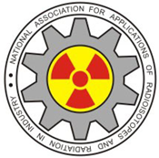
9th NAARRI International Conference
NICSTAR-2026

RADIATION APPLICATIONS: DIVERSE, MATURE AND SUSTAINABLE

March 09-12, 2026, Westin Convention Centre, Powai, Mumbai, India

- Name of the person

- Name of the institution and address

- Registration Done/Yet to be done

- Duration of stay From To

- Payment (To be made at the reception of the Guest house)

- Any other information

Note-
- Only few accommodations are available in BARC training school hostel Anushaktinagar, Mumbai-94 and will be allotted on first cum first serve basis.

- Request may be sent to Shri Pravin Kumar, Convenor Local arrangement committee
(Mobile No- 9820253845, pravinkmr100@gmail.com & copy to naarrimumbaigj@gmail.com)

